Working in Partnership to Foster Collaborative Action for Health Equity

On 23rd February 2024, the NTU Eastern Africa Centre (EAC) hosted a side event on “Working in Partnership to Foster Collaborative Action for Health Equity” during the two-day People’s Health Conference: Advancing Health Equity through Collaborative Action. This event was part of the EAC’s commitment to strategically build global partnerships and improve health equity in marginalised settings. Representatives of the networks associated with the EAC (NTU-Mak Partnership, Pan-African Mental Health Research Network, Eastern Africa PhD Hub, LIMPRINT, and the AfrIE Research Hub) discussed how partnerships play a proactive role in addressing health disparities through collaborative actions; addressed the need for sustainable and equitable partnerships not only within Eastern African countries but also extending to Afro-Caribbean and other global community settings; discussed how to foster a culture of shared learning and support among academic, community, and other relevant entities; and highlighted the strategies that can serve as examples for institutions and organizations globally, to help understand effective approaches to health equity through collaborative action. The Centre was not only represented by people in academia but had a key stakeholder (Mariam Nakirijja) who plays a pivotal role in her community as community health worker and entrepreneur. In her presentation Mariam said:
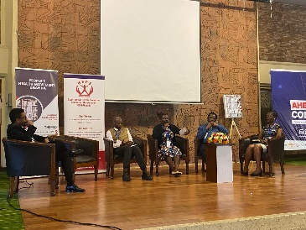
“Look at me now even as a community health worker, I find myself privileged to be seated with Professor(s) and Dr(s) speaking to you and I have even travelled to speak at a conference at Oxford University. This is all due to the partnership between NTU and Makerere University which has even helped me establish a Skilling Centre for my community.” - Mariam Nakirijja, Community Health Worker.
The conference marked a significant step in NTU EAC's dedication to creating impactful global partnerships and advancing health equity in marginalized settings. The participation of representatives Professor Linda Gibson, Dr David Musoke, Dr Mathew Nyashanu, Dr Pamela Wadende, Sally Bashford-Squires, Grace Lubega, Mariam Nakirijja, and Michael Obeng Brown from key networks associated with the centre underscored the proactive role partnerships play in addressing health disparities through collaborative initiatives. Overall, the discussions illuminated the path toward fostering a culture of shared learning and support among academic, community, and other relevant entities offering insights into effective approaches for achieving health equity through collaborative action on a global scale.
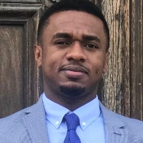
About the Author
Michael Obeng Brown

Michael Brown is the NTU-Mak Partnership Coordinator at NTU and a PhD candidate in Public Health and Economics at the Nottingham Business School.

Other Conference Photos
- Michael introducing panel members -
- Prof Linda Gibson joining online -
- Dr Pamela presenting for the PAMHRN -

