Researching the Lived Experience of Ordinary Working Families

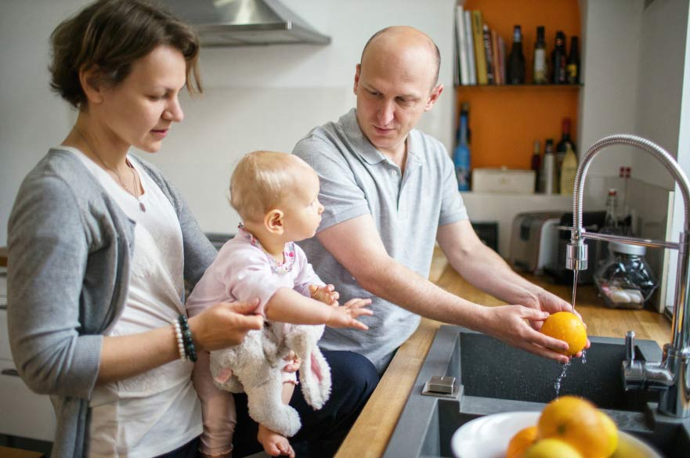

Over the past decade, the global recession has led to UK-wide financial strain. Frozen wages, reduced benefits and raised costs have affected working families across the income spectrum, with a third of the population reporting feeling a degree of economic insecurity. As a result, more people now feel themselves to be in financial hardship: higher income households are often no longer able to meet financial commitments and are accruing substantial debts, whilst low earners can be vulnerable to job insecurity and move in to and out of poverty. Nottingham Civic Exchange (NCE) has carried out research to identify and study these ‘Ordinary Working Families’ (OWFs), finding that this experience of economic insecurity occurs across a range of income brackets. In other words, the experience of hardship depends upon how the household perceives and responds to the challenges it faces. Ongoing work by NCE has begun to focus on Economic Insecurity and how work and concepts of Good Work can impact on citizens.

Against this background, the role of social relationships in providing resilience to economic strain (both insecurity and hardship), has recently been noted. Individuals who are well-integrated into cohesive families and communities cope better with economic strain than those who are isolated. In turn, financial strain undermines social integration, through limiting the ability to participate in community life, as well as through increased stress on family relationships. In effect, there appears to be a bidirectional relationship between the experience of economic strain, and family and community inclusion. However, missing from this analysis is an explanation of *how* family and community dynamics promote economic resilience and *why* financial challenge undermines these protective properties.

Our current programme of work considers how the psychology of group behaviour can be applied to understand the dynamics of financial coping in OWFs. As part of an approach to researching group memberships and health known as the ‘Social Cure’, our previous research has shown that a strong sense of family identity is associated with physical and mental health, while community identification predicts wellbeing and resilience to future threats. We bring this understanding to bear on the experiences of OWFs by examining the challenges they face, how they use (or fail to use) collective resources, and how economic hardship affects the ability of families and communities to support their members.

To date we have undertaken two strands of pilot work in this area:

**Pilot interviews with members of Ordinary Working Families across Nottingham.** We are conducting 16 interviews with a strategically selected range of members of Ordinary Working Families across Nottingham. Using a person-centred approach, we have asked them to tell us about the challenges they face in their daily lives, and how they work with others to overcome them. Our initial data shows a wide range of experiences among families within this category and highlight the high levels of stress and anxiety caused by economic insecurity. Our in-depth analyses will examine the causes of these concerns, identify the barriers to seeking and receiving support to deal with these financial pressures, and suggest ways in which local services and government could more effectively meet the needs of this demographic.

**Community surveys of economic stress and wellbeing across Nottingham.** We have conducted surveys of residents’ community integration, family support and economic stress in five separate areas across Nottingham. From our 1200 responses, we are exploring the factors that reduce financial stress and help family members cope with unexpected financial challenges. Our initial results show a strong negative impact of financial stress on wellbeing and suggest that family and friends can play an important role in helping individuals cope with financial challenges. However, these effects differ across the different areas, suggesting an important role for community identity and resources on financial coping.

#### Nottingham Civic Exchange Publications

[Addressing Economic Insecurity](https://www.ntu.ac.uk/__data/assets/pdf_file/0037/496657/rsa-addressing-economic-insecurity-report.pdf)  
Working with the RSA we have produced this report which makes the case that economic insecurity is a political, economic and societal challenge that public policy must understand and address. This report develops the policy background surrounding our Out of the Ordinary programme of work.  
January 2018

[D2N2 Inclusive Growth Plan: Considerations for the Strategic Economic Plan](https://www.ntu.ac.uk/__data/assets/pdf_file/0016/541510/D2N2-Inclusive-Growth-Report-Final-291017.pdf)  
With NTU's Economic Strategy Research Bureau and the RSA, we produced a report highlighting the potential of taking an inclusive growth model for the LEPs new Strategic Economic Plan.   
November 2017

[The technicalities of Out of the Ordinary income and earnings data](https://www.ntu.ac.uk/__data/assets/pdf_file/0027/424908/out-of-the-ordinary-technical-working-paper-august-2017.pdf)  
Following the publication of our first report from Out of the Ordinary, we are publishing a more detailed technical paper which showcases the detail behind this first reports work on income and earnings.   
August 2017

[Out of the Ordinary](https://www.ntu.ac.uk/__data/assets/pdf_file/0026/362933/Out-of-the-Ordinary-final-report-reduced.pdf)  
Exploring the lives of ordinary working families  
June 2017