The Economic Exclusion of Africa in the 21st Century World System

A system analysis of the challenges impacting the economic inclusion of African nations into the 21st century global economic system

By: Fabiha Begum, Leo Shoebridge, Nathan Jones & Tom Wood

Table of Contents
. .
Challenge Summary 3
System Map Summary 3
Internal Problems 4
Inter-continental Conflicts 4
External Factors 5
Global Influences 5
GDP per Capita, 2018 6
Impacts of Colonialism 7
Chinese Investment or Exploitation? 8
Western Oversight 9
The EU and Africa 9
The US and Africa 10
Solution Programmes 11
Concluding Statements 12

Challenge Summary

Africa has long been known as a ‘gold mine’ of natural resources, spanning from oil to valuable metals and minerals. Therefore, it may be confusing as to how it, as a continent, does not boast a greater wealth for its citizens. Following their colonial pasts, many countries are still facing the effects from when European powers exploited the continent and have since been unable to modernise like many other continents. One reason for this is that Africa has not been included economically in the intricately linked 21st century international system. Through our research we have been able to identify a multitude of reasons for this and we will discuss the causes and effects of some to suggest potential solutions.

System Map Summary

We have also made a system map showing the relations between key actors and their place(s) within the system. We have also looked at the actions that can aid the inclusion of Africa in the 21st century. In addition, we have explored what can stifle its development. The map shows the economic powerhouses of the African Union (AU) and several other countries involved in key issues to be discussed. It also shows that the EU, US and China have links with the African Union, along with other important external organisations.

From our qualitative coding, we were able to uncover existence of various key actors within Africa’s struggle to compete internationally on the economic stage. The US, China and members of the European Union have all affected Africa’s economy and its inclusion in the 21st century, highlighting that the African Union is not only influenced from within the continent. Through research we have discovered the ways in which these influencers have either aided or hindered the AU’s strategies to boost economic security for Africa as a whole in the international system.

Internal Problems
.
Inter-continental Conflicts
One problem within Africa that is currently hindering its economic inclusion is conflict, both intrastate and interstate. Several African nations are internally unstable. Examples of nations which have recently seen, and have continued to have seen, severe conflict from within include:
- Egypt (Egyptian revolution, 2011)
- Somalia (Civil War, 1991-Present)
- South Sudan
  - Democratic Republic of Congo (Ituri Conflict, 1999-Present)
- Libya (2 Civil wars within 3 years, 2011-2014+)
However, African states also come into conflict with one another. One example of this is the conflict between Nigeria and Ghana. There has been historical tension between the two for decades, but in recent years we have seen this exacerbated. Nigerians are now prohibited from running small businesses in Ghana, while Nigeria has closed its borders to many regional imports. This shows that Africa does not only have to surmount to challenges on a global level but within itself. Ghana’s president has asked for talks regarding this issue, but it remains one of many problems between AU countries. This can be seen as a contribution to the reasons why the AU is seen as less of a key trading partner for other international actors. It does not always act cohesively and, therefore, does not form a unified bloc, which discourages investment or equal partnerships with global actors due to this perceived instability.
- An example as to where this is reflected within Africa itself could be seen in 2020, when South Sudan was banned from AU meetings temporarily as they couldn’t pay their membership fees. This was purportedly due to financial difficulties stemming from the Covid-19 pandemic. This meant they could no longer vote in African Union matters while the fees were overdue. The exclusion of South Sudan serves as an interesting comparison to the main issue. Africa is excluded economically, making it more difficult for them to have a say in global issues, and this applies similarly to South Sudan within Africa due in part to its economic power.

External Factors
.
Global Influences
Another important issue facing Africa and the African Union is deciding how they wish to deal with external influences on their economy. Economic growth across Africa is slow due to a lack of infrastructure being built or being built at a 21st century standard. To be able to be included economically in the modern-day international system, there needs to be an increase in the rate of construction of sustainable areas of investment. Although, despite the plentiful natural resources in many African states, they are often reliant on external investment to be able to harness these resources. Examples of natural resources can be seen here:
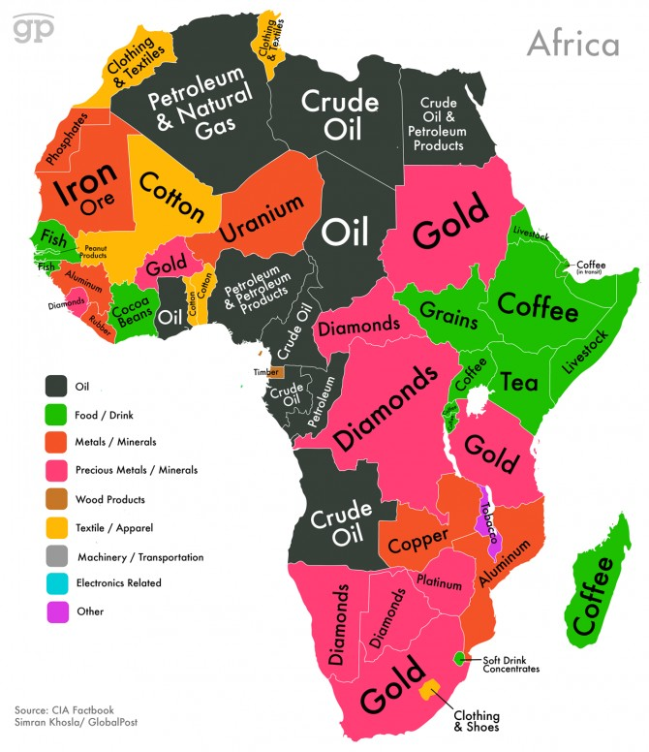

Furthermore, it is necessary to provide opportunities to attract big businesses and institutions to encourage economic growth. The focus needs to be on providing relevant infrastructure to create jobs with type-specific training, increase job security, as well as focus on technological advancement so that crises and disasters, such as disease outbreaks, don’t prohibit future economic growth. To do this, they rely on global powerhouses such as the US, EU and China, however, the interests of external states are profit-related, and do not necessarily focus on the infrastructural development required by these countries. This can be seen as an extension of colonialism, given the past and present exploitation of these states for economic gain.

GDP per Capita 2018
The sheer nature of the problem facing Africa as a continent can be seen below.
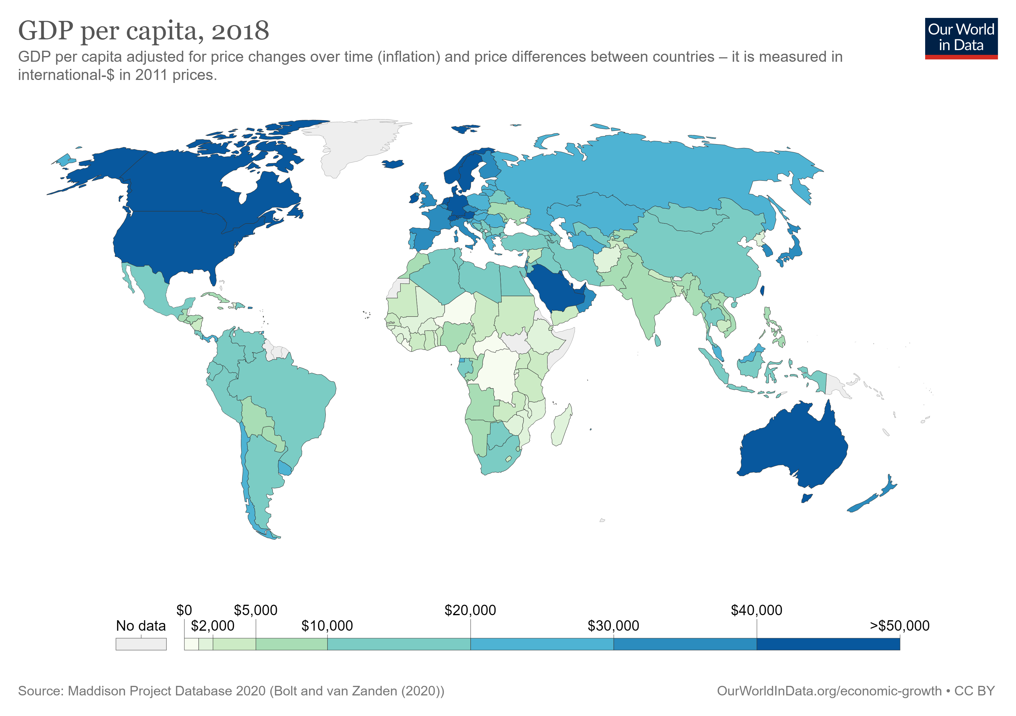
This chart shows the GDP per capita of each country after being adjusted for inflation and price differences between countries. No country in Africa had a GDP per capita over $30,000 whereas western countries like Canada, the U.S.A. and Germany all have values up to and exceeding $50,000. This can be interpreted as the African countries have a greater population size therefore, their values would naturally be lower than western competition. This would be supported by the 2017 World Population Data Sheet, that shows the top 10 countries ranking in fertility rates are countries from the African continent. However, this simple explanation does not allow for contextual information pertinent to the debate. It does not address the very high levels of infant mortality in the Continent, nor does it address the lower life expectancy.

Impacts of Colonialism
European occupation within the region has led to drawbacks when approaching African integration. The main reason for this was Africa’s relative poverty, which was primarily due to European colonialism, which meant there was less funds available to rebuild and further invest into the region. During periods of colonisation, Sub-Saharan Africa was used by Europe to create and expand European markets, as various commodities could be profitably produced by Africa. This was due to Africa's’ land-labour ratio which gave them a comparative advantage in land intensive primary productive capabilities. This can be seen namely in West Africa, whereby the indigenous population were taken advantage of these supply-side features, to expand overseas markets. Furthermore, integration within Africa would foster better development for the region, as integrating within foreign markets would be competitive due to Europe having a stronger economy from colonised periods. Overall, development within Africa had been halted by colonisation, due to relative poverty from a lack of infrastructure and investment schemes in domestic industries.
- Colonisation left the newly independent states unprepared to integrate into the modern global system
- Left vulnerable to outside influences and pressures e.g., The Soviet Union
Furthermore, colonialism can explain the hesitancy of African states to accept US investment and instead prefer Chinese investment, due to the greater colonial presence of the US. A decade ago, China overtook the US in terms of trade imports to African states. Between 2001 & 2011, Chinese exports to Africa raised from $4.4bn to $56.3bn, with a substantial amount going towards funding infrastructure & defence projects in Nigeria. Chinese invested projects, such as the ‘Belt & Road’ project, have helped shape the economies of many heavily invested in states like Nigeria & Ghana. It has also been stated in a recent survey that “Nigerians living near a major Belt and Road project grew more positive toward China after it was completed”. Here we are able see again in the rail & networking projects in East Africa, the notable shift from colonial ties with the US, towards China. This was reflected in coding research, which saw more positive discourse from African state leaders regarding China than towards the US. This infrastructural development originating from China moves African states closer to inclusion within the 21st century economy.

Chinese Investment or Exploitation?
.
In addition to global influence, China is also trying to improve its military presence, emphasising the point about external states’ intentions being profit related. By investing in Africa, especially in the east, China has been able to set up its first over-seas military base in Djibouti after investing approximately $14 billion into networking and infrastructure projects. Other rail projects in Ethiopia and Kenya will help these 3 key states become increasingly connected in the future as China invested the same rail networking system in each state, meaning the lines will be able to be connected, heightening the chances of economic growth in the area through regional trade. This seems to be pushing the invested nations in the right direction to being more interconnected and resourceful to each other. However, it can also be said that the exploitation of African nations for Chinese military and global influence continues to emphasise the issue of dependence on more advanced global economies, therefore subjugating them to being third-party organisations in their own trade deals.

Western Oversight
.
The EU and Africa
The EU pays extra close attention to Africa and its nations also, with organised trade dating back to the Lomé Conventions I-IV of 1975-2000. The consequent Cotonou Agreement, 2000-2020, set out to ‘eradicate poverty’ by helping the African nations to become more fully integrated into the world economy. The African Union and European Union initiated this goal through the Pan-African Programme. This provides support and promotes continental integration by administering trans-regional & continental projects. Along with this programme, the African-EU partnership set up the African Peace Facility, established in 2004, whereby it has provided €2.7 billion to support efforts to prevent and manage conflicts. Following on from this, the European Union and the African Union set up the Joint Africa-EU strategy (JAES), adopted in 2007, with the purpose of intrinsically linking the African Union members politically as well as economically, to increase the presence of Western liberal democracy. Talks are still ongoing over proposals about adopting a new strategy, since the Cotonou Agreement expired last year. However, there has been 5 partnership trends set out that will build upon this relationship:
- Green Transition and Energy Access
- Digital Transformation
- Sustainable Growth and Jobs
- Peace, Security and Governance
- Migration and Mobility
This signifies that this is not the end of Euro-African trade and shows the solutions to the problem are being tackled. The move to thinking about taking control of the future challenges earlier, is helping to secure the cooperation that is already evidently there so Africa can become included on a larger scale within the modern-day international system.

The US and Africa
The US has also provided monetary support and investment opportunities to the continent, with it being the single largest source of direct investment into Africa. However, there has been a stark decline in trade in the last decade. Especially when Trump was in office, high-profile diplomatic posts remained unfilled, leading to a decrease in levels of cooperation between the ‘global hegemon’ and African nations. Many of the positions are ordered in terms of importance of trade, with South Africa being top of the list. Unlike other states such as India, China, & Turkey, who are trying to expand their international presence in Africa, the US, under Trump, fell short of their diplomatic responsibilities with reports of government officials, including the President himself, making highly offensive statements about Africa and its nations. If the most influential state on Earth is not attracted by the trade possibilities that Africa could supply, what hope is there in becoming a desirable trading bloc?
On the other hand, the continued flood of investment from other states may have had an effect on the levels of trade across the board. The countries who have increased trade relations with African nations include:
- Russia
- China
- Turkey
- India
The increasing amount of business competition from around the globe, is history repeating its colonial past with another ‘scramble for Africa’ taking place. If the US does not want to be pushed out of line, further strategies need to be implemented to be able to engage in this trading battle.

Solution Programmes
.
The good news is that there are many solutions to this big problem. The AU’s main concern is to unite its members to form a cohesive and appealing trading bloc. To do this they must:
- Focus on negotiating peace between its members, of which are in conflicts, so that it can promote intercontinental trade and rely on each other instead of foreign exports, consequently increasing the likelihood of economic growth coming from within the continent
- The AU needs to help, or provide the resources to find help, build the relevant infrastructure that is needed. This would create jobs which would need to be facilitated by appropriate training and decrease the pressure on South Africa and Nigeria’s economies, as they make up 50% of Sub-Saharan Africa’s GDP alone
- Another focus needs to be on technological advancement so that outbreaks & disasters stop draining the economy
The issues described before can be solved by increasing the amount of business expansions or investment opportunities with the emphasis on cleaner and sustainable practices and institutions. One of the current ways this development is being encouraged is through charities such as Oxfam. Oxfam and other charities work to provide the framework for development as well as the most essential needs for survival to people in poverty. If these basic needs are met and infrastructure is put in place, it then becomes more practical for development to occur and economic growth becomes possible. Other factors that have been implemented to help bridge the economic gap include the World Bank Group 2030 goals, in which it aims to reduce extreme poverty to no more than 3% in the world. As we know, most of the world’s cases of extreme poverty lie within Africa. Here we can see where global institutions are helping to supplement the issues which African nations have had to tackle, especially since colonialism.

Concluding Statements
.
Overall, the effects of inter and intra-continental conflicts, old colonial impacts, trade exploitation and lack of infrastructure have contributed towards Africa’s economic issues. We have explored the reasons why these issues have affected Africa’s global position, or rather lack of, and suggested methods to help with solving these problems. Africa is still an instable focus area, where one false decision could mean the end of all the work and resources that have been pumped into projects or could brighten the future of African economics. It is up to the larger economies of the world to provide enough investment opportunities; however, they also need to balance this scale without burdening African nations with a dependency complex.

