- Enter this website: http://www.sculx.cn/, and click here to apply.
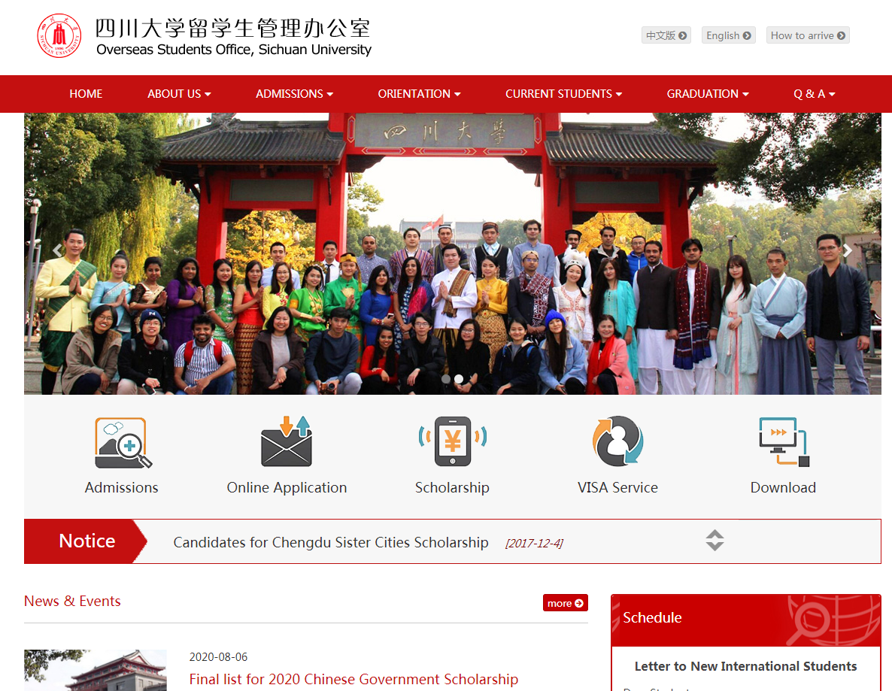

2.Click here to register.
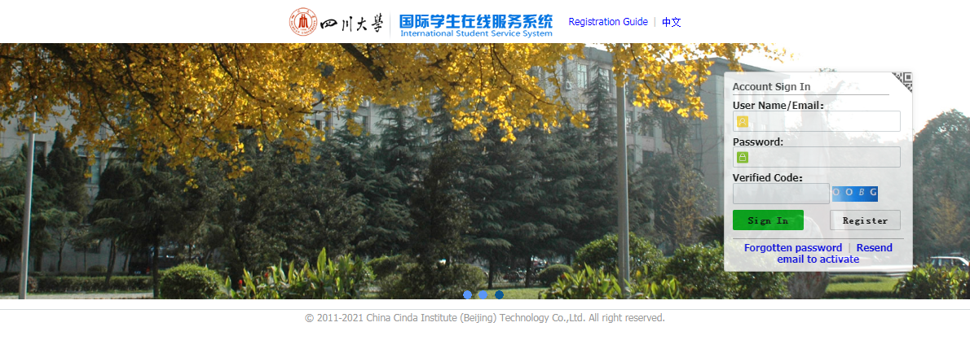

- Accept the registration agreement and fill in the registration information.

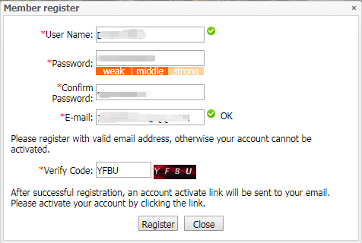

- Go to your mail box to activate the account.
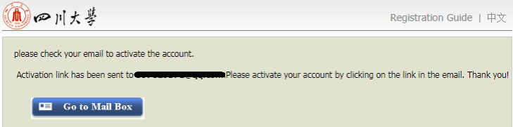

- Click the link to activate your account.
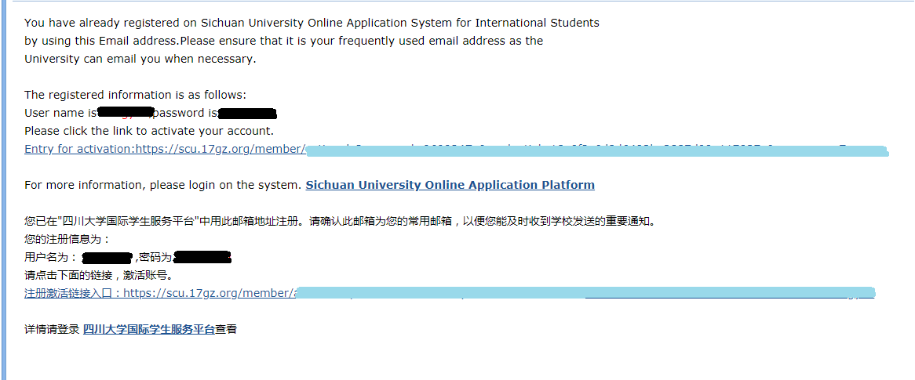

- After clicking the activation link, it will automatically jump to the interface of step 8. If there is no automatic jump, please enter https://scu.17gz.org/member/login.do , fill your user name and password to sign in.
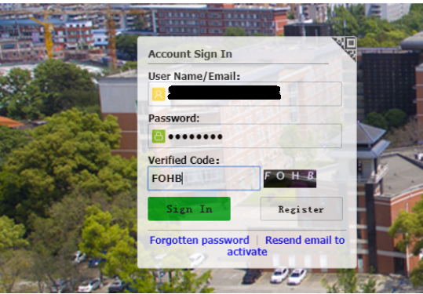

- Click “ ONLINE APPLICATON” .
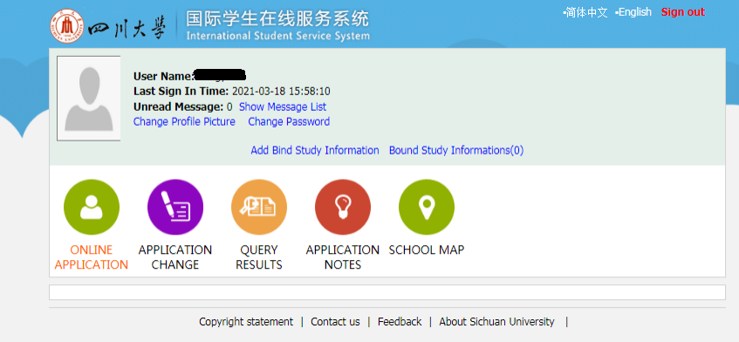

- Click here to agree the regulation and go on to the next step.

- Choose Partner University Program Students, and click “next”.
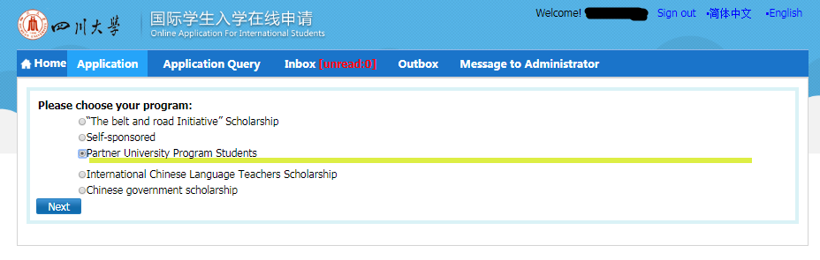
- Choose your type, and click “next”
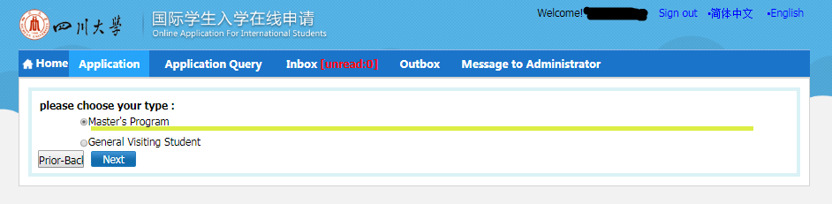

- Find the major you want to apply, and click “Apply”.
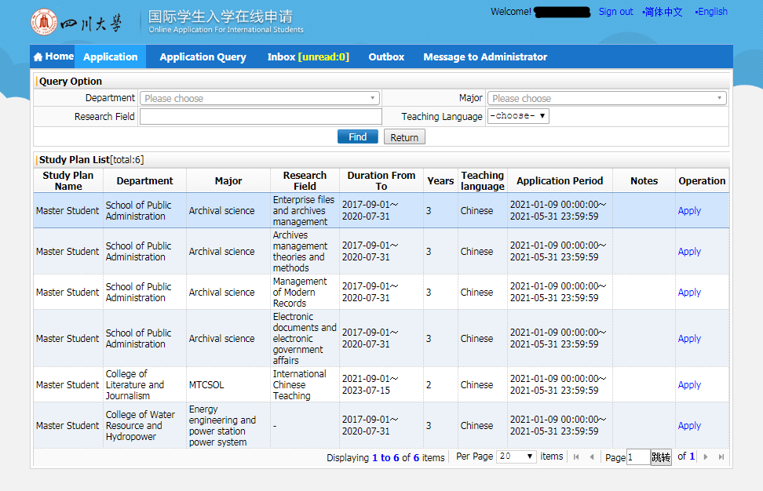

- Fill the form, and click “save and next”.
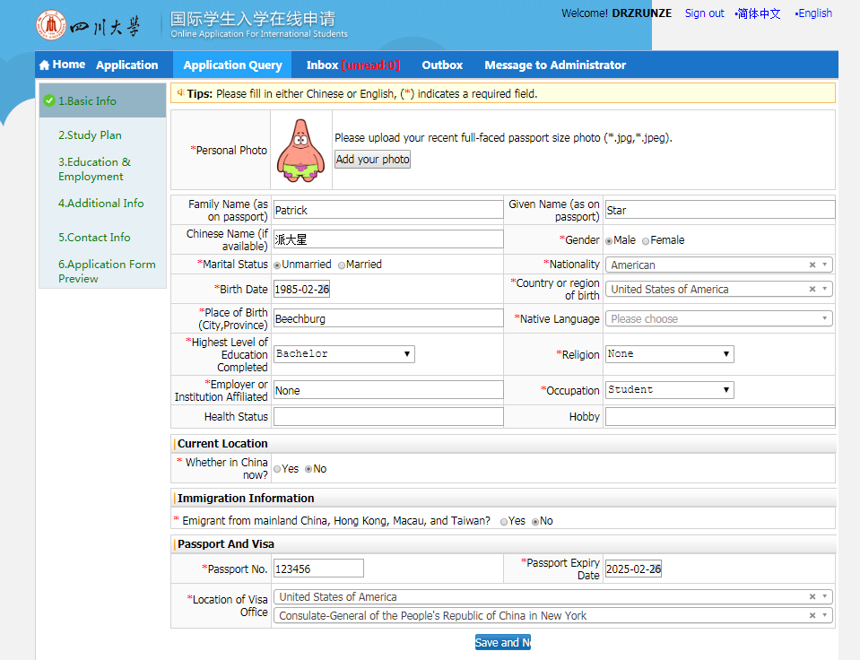
- Fill the form, and click “save and next”.
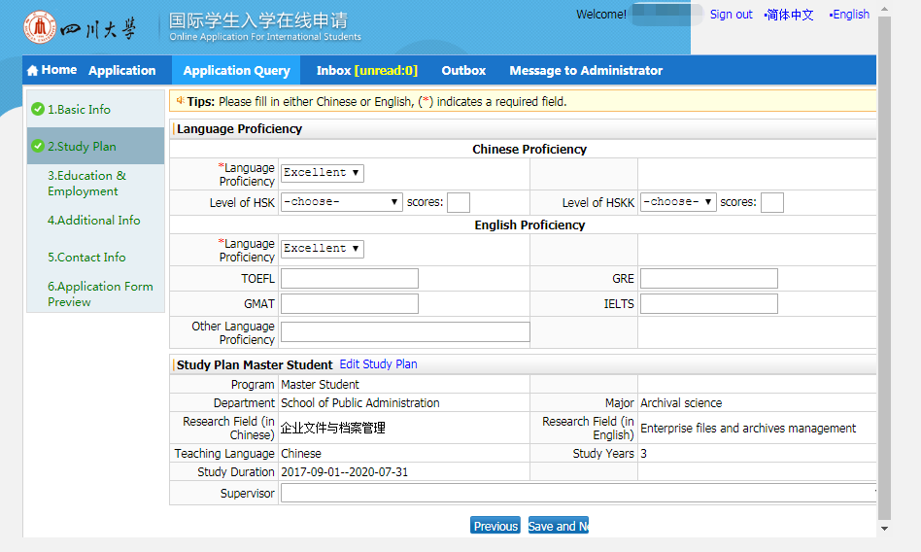

- Fill the form, upload the required materials and click “save and next”.
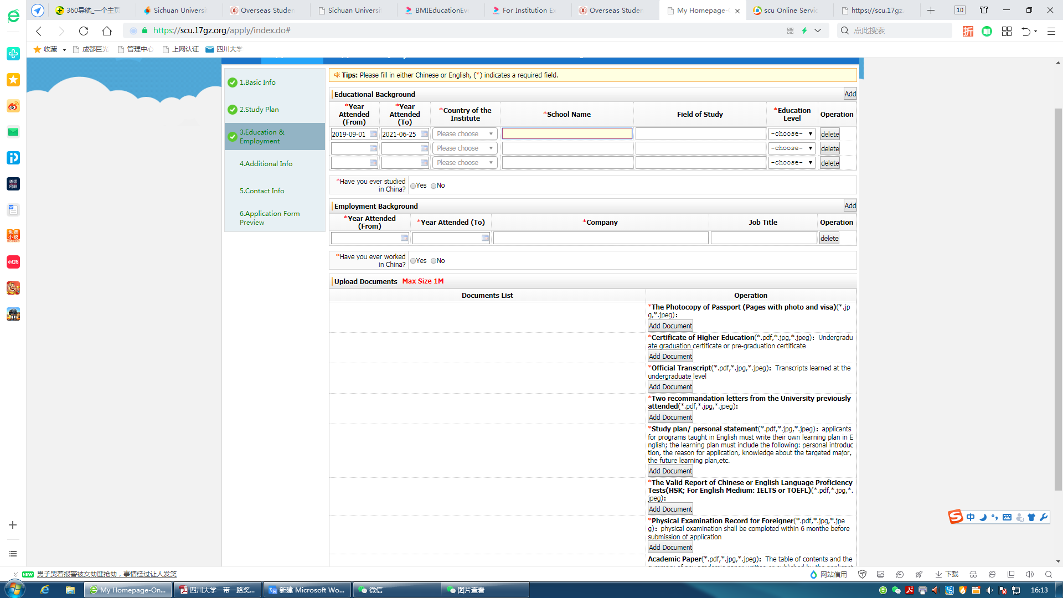
- Fill the form, and click “save and next”.

- Fill the form, and click “save and next”.

- Check the information in the application form preview, make sure there’s no mistake and click “Submit”. Then, your application is completed.
