QHS 6B
QH Supplement 6B: Course Review Plan (template for courses)

Using the Course Review Plan
  - Through the review of priority quantitative data (see: The TEF/B3 Performance Dashboard) and additional qualitative evidence, this plan promotes a cycle of assurance and quality improvement.

The Plan
- Serves as a framework to capture opportunities for improvement, action and associated evidence of impact to ensure effective maintenance and ongoing enhancement of the course.
- Ensures that course review and planning align with institutional and sector regulations, while supporting the management of quality, student experience and outcomes.
- Is primarily for course leaders, Heads of Department and Deputy Deans.
- Will inform the annual SASQC report to ASQC.
- Must be completed and prior actions updated in each year of the approval cycle.
- Must include all course offerings, modes and cohorts.
- As part of NTU's commitment to RECSAT, you are encouraged to record any observations on ethnicity and course performance data (continuation, completion and progression). This may take the form of comparing course performance across different ethnicities, but you may wish to explore School Insights data and intersectionality more broadly to align with School priorities.

Re-approval mechanisms
  - All courses are subject to a 5-year fixed-term approval period. Towards the end of the approval period, courses must be evaluated to determine the appropriate re-approval route, as per the Course Review Policy (Quality Handbook Section 6). The re-approval route is dependent on a range of criteria including, but not limited to, trends in the Official B3/TEF data and the level of changes to the course since last approval.
  - While the Course Review Plan is structured as a five-year cycle, Schools may determine that certain courses require re-approval earlier than the five-year point. This may be due to PSRB timelines, regulatory requirements, or course performance.
Additional information
- Please see Quality Handbook Section 6 for more information on Re-approval.

School Re-approval
  - A course may be Reapproved at School level if all the following conditions are met:
- Continuation, completion and progression are above the B3 threshold.
- There are no concerns identified based on a 3-year trend analysis.
- Identified course changes fall within the remit of School approval, as per Quality Handbook Section 5 (Appendix 1 & 2). In this instance, SASQC course change deadlines must be met.
  - If a course has existing exemptions from the Course Design Requirements (Quality Handbook Section 12), and it is intended to retain these, the School must seek approval from ASQC before either School or University-level Re-approval.

University Re-approval
  - If a course does not meet the above criteria, then University-level Re-approval via the Academic Course Approval Sub-committee is required.
  - In the same way that new courses are subject to post-approval course start date lead times (see QHS 5K), as are Re-approvals. These considerations determine when teaching on a new or revised course can commence. Depending on the nature of the proposed change (where a change is justified), the School may seek exemption from such lead times in accordance with QHS 5K. Where substantive changes are sought, a teach-out plan may be needed to ensure continuity of delivery and academic standards for existing student cohorts.

Definitions
  - ‘B3’ metrics refer to the Office for Students’ ongoing regulatory condition, which defines the minimum requirements for the quality and standards of higher education courses in the UK.
- Continuation (B3 metric): The measure of how many students continue their studies from one year to the next, reflecting retention rates.
- Completion (B3 metric): The successful finishing of a degree or course by a student, often within a set timeframe.
- Progression (B3 metric): The advancement of students from their studies and into positive outcomes, such as employment or further study. This includes measuring how well students move from one stage of their education to the next, and their success in achieving their intended career goals or continuing education.
  - The Course Review Plan must include data and/or screenshots from the OfS Outcomes Table in School Insights. Additional tables may be included to support your data analysis e.g. OfS Split-Indicator Chart.
  - For the Continuation and Completion metrics only, ‘NTU OfS metrics’ are available in School Insights to allow colleagues to view a broader range of academic years, including more recent data. The intention is to help identify the current direction of travel. Combined with an understanding of how TEF performance is measured, this should support judgements about whether future TEF datasets are likely to show improvement or decline, and again whether any specific action may be warranted.

Course Overview Data
Course Title and Award
Course Leader/s |  |  | External Examiner/s
Accreditation/PSRB (if applicable) |  |  | Date of last PSRB approval (if applicable)
Course Modes/ Offerings | e.g. Full Time, Part Time, Sandwich, number of cohorts per year
The below fields are minimum requirements, as articulated in the Course Review Policy
Approved exceptions to Course Design Requirements (QH12) for this cycle (if required).
Date of last Course Approval |  |  | Date CourseLoop & website info checked.
CourseLoop Link
Course changes approved by SASQC within the period – For changes already recorded in CourseLoop, it is a School decision whether they need copying to here.

Change |  | Module(s) affected |  | Date approved | Date implemented

Year 1

Review
Note for course team: This space is to insert the OfS Outcomes Table. To display several study modes select these as separate courses.
The below screenshot is an exemplar to be replaced with your own course data.
Additional tables may be included to support your data analysis e.g. OfS Split-Indicator Chart.

Entirely new courses will not have quantitative data to consider and should consider wider qualitative data in their first year.

Date data/ screenshot taken: [Insert Date]

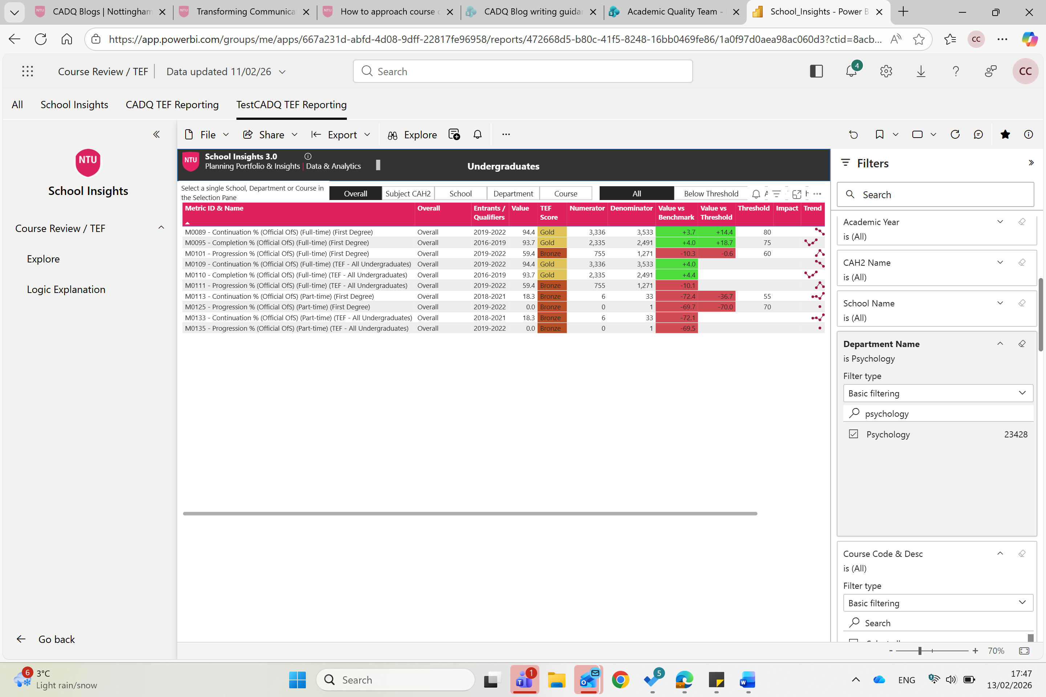

Data and Evidence | Summary Findings
Outcomes of B3 data in the TEF/B3 Performance Dashboard:
Continuation
Completion
Progression
Outcomes of additional course data in the TEF/B3 Performance Dashboard (including, NSS, module failure rates and % Upper Degree)
Student voice: module evaluation, other student feedback, quality of responses to students
External feedback & considerations for development (External Examiner, PSRBs, Accreditation)
Other Feedback which may include staff, Employer, Alumni, Professional services or market insights.

Course Development Priorities
Priority Area | Measure | Owner | Target Date | Complete
 |  |  |  | ☐
 |  |  |  | ☐
 |  |  |  | ☐

Course Highlights
- xxx
- xxx
- xxx
- xxx
- xxx

Leadership comments
Optional space for oversight notes, notable effective practice, progress on development priorities, confirmation of review or escalation of issues by Head of Department or Deputy Dean.

Year 2

Review
Note for course team: This space is to insert the OfS Outcomes Table.
The below screenshot is an exemplar to be replaced with your own course data.
Additional tables may be included to support your data analysis e.g. OfS Split-Indicator Chart.

Date data/ screenshot(s) taken: [Insert Date]

Data and Evidence | Summary Findings
Outcomes of B3 data in the TEF/B3 Performance Dashboard:
Continuation
Completion
Progression
Outcomes of additional course data in the TEF/B3 Performance Dashboard (including, NSS, module failure rates and % Upper Degree)
Student voice: module evaluation, other student feedback, quality of responses to students
External feedback & considerations for development (External Examiner, PSRBs, Accreditation)
Other Feedback which may include staff, Employer, Alumni, Professional services, or market insights.

Course Development Priorities
Priority Area | Measure | Target Date | Complete
 |  |  | ☐
 |  |  | ☐
 |  |  | ☐

Course Highlights
- xxx
- xxx
- xxx
- xxx
- xxx

Leadership comments
Optional space for oversight notes, notable effective practice, progress on development priorities, confirmation of review or escalation of issues by Head of Department or Deputy Dean.

Year 3

Review
Note for course team: This space is to insert the OfS Outcomes Table.
The below screenshot is an exemplar to be replaced with your own course data.
Additional tables may be included to support your data analysis e.g. OfS Split-Indicator Chart.

Date data/ screenshot(s) taken: [Insert Date]

Data and Evidence | Summary Findings
Outcomes of B3 data in the TEF/B3 Performance Dashboard:
Continuation
Completion
Progression
Outcomes of additional course data in the TEF/B3 Performance Dashboard (including, NSS, module failure rates and % Upper Degree)
Student voice: module evaluation, other student feedback, quality of responses to students
External feedback & considerations for development (External Examiner, PSRBs, Accreditation)
Other Feedback which may include staff, Employer, Alumni, Professional services, or market insights.

Course Development Priorities
Priority Area | Measure | Target Date | Complete
 |  |  | ☐
 |  |  | ☐
 |  |  | ☐

Course Highlights
- xxx
- xxx
- xxx
- xxx
- xxx

Leadership comments
Optional space for oversight notes, notable effective practice, progress on development priorities, confirmation of review or escalation of issues by Head of Department or Deputy Dean.

Year 4

Summary of notable impact of any changes in years 1-3
Insert brief summary/ list here:
- xxx
- xxx

Review
Note for course team: This space is to insert the OfS Outcomes Table.
The below screenshot is an exemplar to be replaced with your own course data.
Additional tables may be included to support your data analysis e.g. OfS Split-Indicator Chart.
Date data / screenshot(s) taken: [Insert Date]
Data and Evidence | Summary Findings
Outcomes of B3 data in the TEF/B3 Performance Dashboard:
Continuation
Completion
Progression
Outcomes of additional course data in the TEF/B3 Performance Dashboard (including, NSS, module failure rates and % Upper Degree)
Student voice: module evaluation, other student feedback, quality of responses to students
External feedback & considerations for development (External Examiner, PSRBs, Accreditation)
Other Feedback which may include staff, Employer, Alumni, Professional services, or market insights.

Course Development Priorities
Priority Area | Measure | Target Date | Complete
 |  |  | ☐
 |  |  | ☐
 |  |  | ☐

Course Highlights
- xxx
- xxx
- xxx
- xxx
- xxx

Leadership comments
Optional space for oversight notes, notable effective practice, progress on development priorities, confirmation of review or escalation of issues by Head of Department or Deputy Dean.

Outcome
Continuation, completion and progression are above the B3 threshold. | Yes/No
There are no concerns identified based on a 3-year trend analysis | Yes/No
Identified course changes fall within the remit of School approval, as per QH Section 5 (Appendix 1 & 2) and will meet SASQC course change deadlines. | Yes/No

☐ University Re-Approval ☐ School Re-approval ☐ Discontinuation ☐ Temporary Suspension

Rationale for Outcome:
Please explain why this decision has been made.
Changes for consideration at Re-approval | Reason

Year 5

Review
Note for course team: This space is to insert the OfS Outcomes Table.
The below screenshot is an exemplar to be replaced with your own course data.
Additional tables may be included to support your data analysis e.g. OfS Split-Indicator Chart.

Date data / screenshot(s) taken: [Insert Date]
Data and Evidence | Summary Findings
Outcomes of B3 data in the TEF/B3 Performance Dashboard:
Continuation
Completion
Progression
Outcomes of additional course data in the TEF/B3 Performance Dashboard (including, NSS, module failure rates and % Upper Degree)
Student voice: module evaluation, other student feedback, quality of responses to students
External feedback & considerations for development (External Examiner, PSRBs, Accreditation)
Other Feedback which may include staff, Employer, Alumni, Professional services, or market insights.

Course Highlights
- xxx
- xxx
- xxx
- xxx
- xxx

Leadership comments
Optional space for oversight notes, notable effective practice, progress on development priorities, confirmation of review or escalation of issues by Head of Department or Deputy Dean.

Information for Re-approval
Date of School/ University Re-approval (as applicable):

Course design exceptions approved by ASQC:

Insert approved exceptions and date of ASQC approval

School Re-approval
This section should be completed for School Re-approval.

Course Development Priorities
Priority Area | Measure | Target Date

Additional Narrative to support Re-approval

Insert Narrative here.

Outcome
☐ Re-approved ☐ Not approved: escalated for University consideration ☐ Not Re- approved: discontinued/ suspended

School Re-approval comments

Insert required actions, recommendations or noteworthy practice raised in the re- approval.

University Re-approval
This section should be completed when University Re-approval is required.

Summary of action taken to address risk
Priority Area | Measure | Target Date | Complete | Impact to date
 |  |  | ☐
 |  |  | ☐
 |  |  | ☐

Additional Narrative to support Re-approval

Insert Narrative here.

Outcome
☐ Re- approved ☐ Not Re-approved: discontinued/ suspended

University Re-approval comments

Insert required actions, recommendations or noteworthy practice raised in the re- approval.

Teach Out (where required)

Review
Note for course team: This space is to insert the OfS Outcomes Table. See ‘display by course’ to access several study modes.
The below screenshot is an exemplar to be replaced with your own course data. Additional tables may be included to support your data analysis e.g. OfS Split-Indicator Chart.

Date data / screenshot(s) taken: [Insert Date]

Data and Evidence | Summary Findings
Outcomes of B3 data in the TEF/B3 Performance Dashboard:
Continuation
Completion
Progression
Outcomes of additional course data in the TEF/B3 Performance Dashboard (including, NSS, module failure rates and % Upper Degree)
Student voice: module evaluation, other student feedback, quality of responses to students
External feedback (External Examiner, PSRBs, Accreditation)
Other Feedback which may include staff, Employer, Alumni, Professional services, or market insights.

Course Highlights
- xxx
- xxx
- xxx
- xxx
- xxx

Action Plan
Date | Action – update/amend as appropriate for course | Detail/Purpose/Impact | Person Responsible | Review
 | To ensure students have the resources they need to complete their studies
 | To ensure students have the staff support they need to complete their studies including re-submission requirements
 | To remove marketing materials and ensure adherence to CMA commitments
 | To effectively close the programme

Leadership comments
Optional space for oversight notes, notable effective practice, progress on development priorities, confirmation of review or escalation of issues by Head of Department or Deputy Dean.

Please see the Course Review Policy for more information on the scope of the policy and approval durations.
Changes can refer to changes to delivery, practice, or design.

